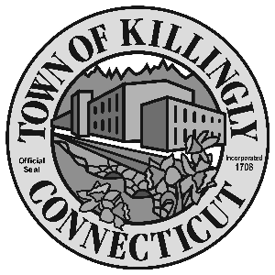
z

OFFICE OF THE TOWN MANAGER
172 Main Street, Killingly, CT 06239
Tel: 860-779-5335 Fax: 860-779-5382

TOWN OF KILLINGLY
FISCAL SUBCOMMITTEE MEETING
October 9, 2018
6:30 p.m.
Killingly Town Hall
Room 204
172 Main Street, Killingly, CT

Council Members:
Chris Dillon
Jonathan Cesolini
David Griffiths
Alt: Ed Grandelski

Agenda

- Call to order
2. Citizens participation
3. Adoption of minutes: May 8, 2018
4. Unfinished business
5. New business:
  - Discussion of 2017-2018 Budgetary Transfers
  - Discussion of non-union/department head raises
  - Discussion and possible action on funds appropriated for Owen Bell Park

6. Other
7. Adjournment

