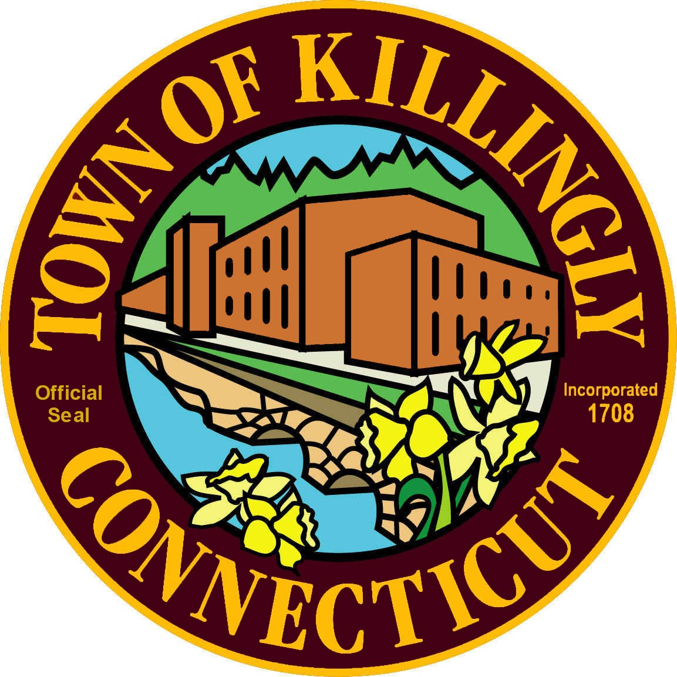
Town of Killingly
OFFICE OF THE TOWN MANAGER
172 Main Street, Killingly, CT 06239
Tel: 860 779-5334 Fax: 860 779-5394

SPECIAL MEETING

Saturday, February 25, 2017
9:00 AM
Town Meeting Room
172 Main Street

AGENDA

- Call to Order

- Roll Call

- Citizens’ Comments

- Discussion of Council’s 2017 Goals

- Adjournment

