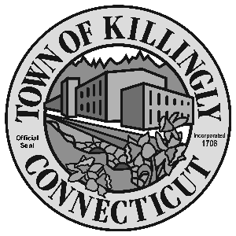

OFFICE OF THE TOWN MANAGER
172 Main Street, Killingly, CT 06239
Tel: 860-779-5335 Fax: 860-779-5382

TOWN OF KILLINGLY
SPECIAL COMMISSION FOR THE CONSOLIDATION OF SERVICES
March 30, 2016
6:30 p.m.
Town Meeting Room
Killingly Town Hall
172 Main Street, Killingly, CT

Commission Members:
John Burns Matt Desrosiers
John Hallbergh Kevin Ide
David Smith Christopher Viens
Alt: Joyce Ricci, Jennifer Thompson

Agenda

- Call To Order – Town Manager
- Election of Officers
3. Citizens Participation
4. Adoption of Minutes of Previous Meeting: December 8, 2014
5. Unfinished Business
6. New Business:
  - Setting monthly meeting date/time
  - Discuss charge/direction of commission and subjects for next meeting

7. Other
8. Adjournment

