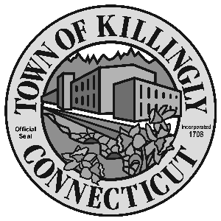

OFFICE OF THE TOWN MANAGER
172 Main Street, Killingly, CT 06239
Tel: 860-779-5335 Fax: 860-779-5382

TOWN OF KILLINGLY
SPECIAL COMMISSION FOR THE CONSOLIDATION OF SERVICES
April 28, 2016
6:30 p.m.
Town Meeting Room
Killingly Town Hall
172 Main Street, Killingly, CT

Commission Members:
John Burns Matt Desrosiers
John Hallbergh Kevin Ide
David Smith Christopher Viens
Alt: Joyce Ricci, Jennifer Thompson

Agenda

- Call To Order – Town Manager
2. Citizens Participation
3. Adoption of Minutes of Previous Meeting: March 30, 2016
4. Old Business
5. New Business:
  - Discuss EDO01
  - Discuss consolidation ideas

6. Other
7. Adjournment

