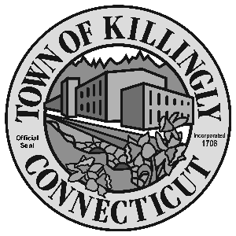

TOWN MANAGER’S OFFICE
172 Main Street, Killingly, CT 06239
Tel: 860-779-5335 Fax: 860-779-5382

TOWN OF KILLINGLY
FISCAL SUB-COMMITTEE MEETING
March 15, 2016
CORRECTED TIME: 6:30 p.m.
Room 102, 1st floor
Killingly Town Hall
172 Main Street, Killingly, CT

Council Members:
Kevin Ide, Chair
Ed Grandelski
Gail Oakley Pratt
David Griffiths, Alt.
Agenda

- Call To Order
2. Citizens Participation
3. Adoption of Minutes of Previous Meeting: January 19, 2016
5. Unfinished Business
6. New Business:
  - Consideration and Action on Shubael Hutchins Trust Fund request.
  - Discuss a resolution to authorize the replacement of the L-60E Loader using the Capital Non-Recurring account funds dedicated to this equipment.
  - Consideration and Action on request for replacement of the public copier for the Library using the Lena P. Tripp Fund.

7. Other
8. Adjournment

