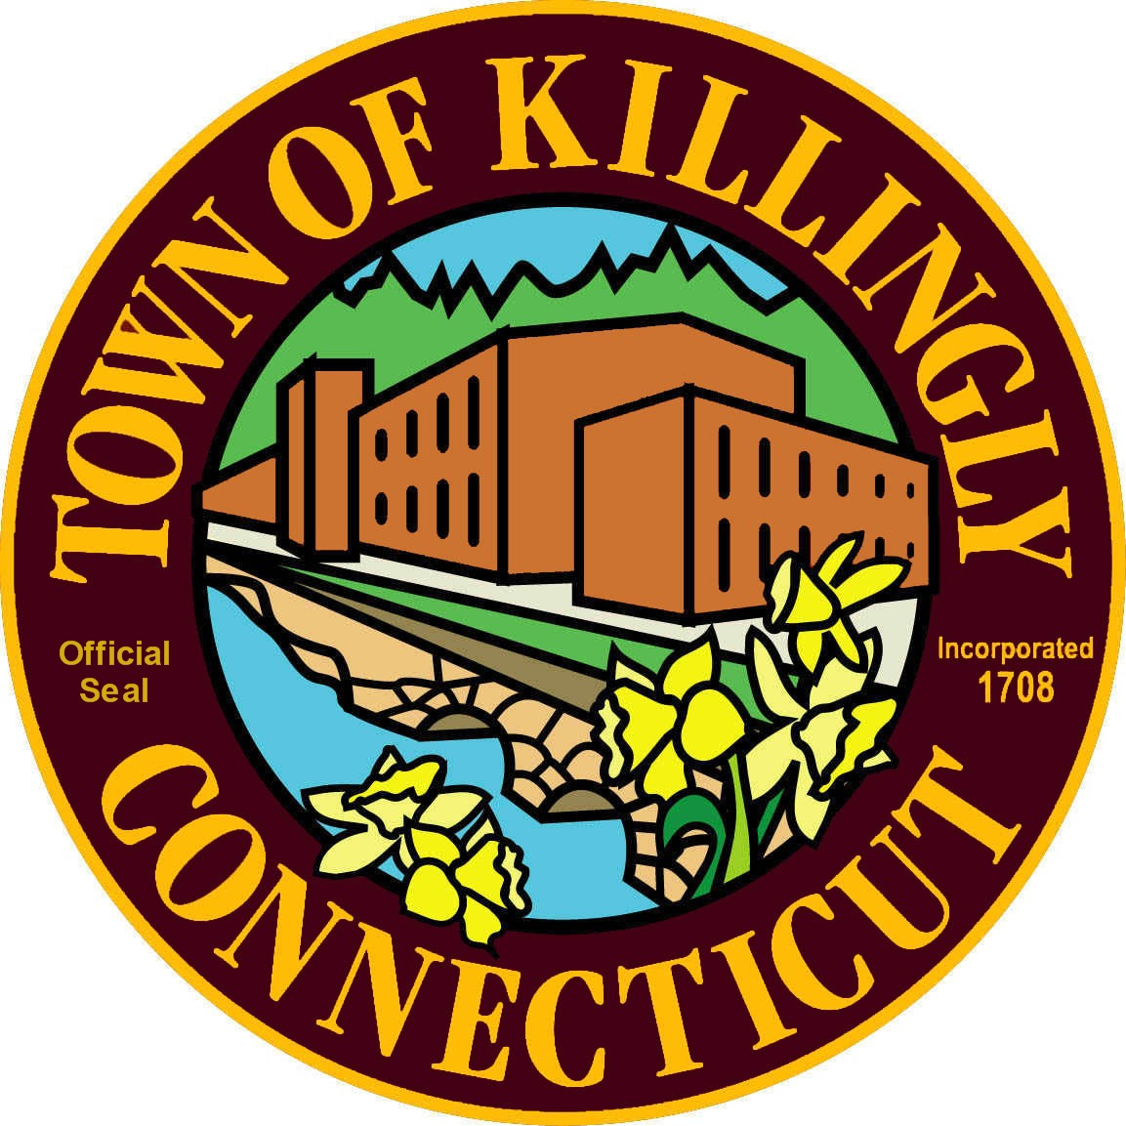
Town of Killingly
OFFICE OF THE TOWN MANAGER’S
172 Main Street, Killingly, CT 06239
Tel: 860 779-5334 Fax: 860 779-5394

TOWN COUNCIL SPECIAL MEETING

Saturday, January 30, 2016
8:30AM
Town Meeting Room
172 Main Street

AGENDA

- Call to Order

- Roll Call

- Citizens’ Comments

- Goal Setting Session

- Adjournment

