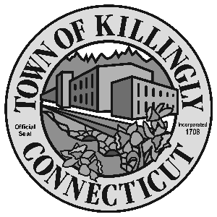
0 z

172 Main Street, Killingly, CT 06239
Tel: 860-779-5335 Fax: 860-779-5382

TOWN OF KILLINGLY
BOARD OF ASSESSMENT APPEALS
September 14, 2021
6:00 p.m.
Killingly Town Hall
Room 102

Members:
Dale Dauphinais
Kevin Gaudreau
Russell E. Lavigne II

Agenda

- Call to order
- Citizens Comments
3. Approval of minutes of April 27, 2021 hearings
4. Unfinished business
5. New business:
- Motor Vehicles appeals from 2020 Grand List

6. Adjournment

