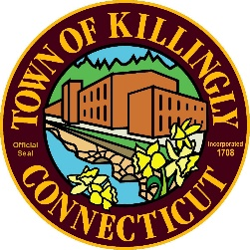
TOWN OF KILLINGLY
TOWN ENGINEER'S OFFICE
172 Main Street, Danielson, CT 06239
Tel: 860-779-5360 Fax: 860-779-5392
TOWN OF KILLINGLY
SOLID WASTE SUBCOMMITTEE
May 26, 2021 at 6:00 P.M.
KILLINGLY TOWN HALL
TOWN MEETING ROOM
172 Main Street, Killingly CT 06239
Commission Members:
Jason Anderson
Ernest Lee
Ed Grandelski

MEETING MINUTES
- Call to Order: Ernest Lee call the meeting to order at 6:02pm
- Citizens Comments: None
- Adoption of Minutes:
  - February 10, 2021 Special Meeting Minutes.
Ed Grandelski motioned to approve the February Minutes Jason Anderson seconded the motion all in favor. Motion approved.
- Tim DeVivo- Willimantic Waste Paper Co. Inc. absent
- Finance Report: David Capacchione gave an overview to the committee. Ed Grandelski motioned to approve the finance report Jason Anderson seconded the motion all in favor. Motion approved.
- Unfinished Business
  - DEEP-Municipal Waste Reduction Initiative discussion ensued on the reduction initiative also the new bottle increase to 10 cent and includes various containers.
- New Business:
  - Tonnage Report: David Capacchione gave an overview of the tonnage report.
- Other Discussion Items: none
- Adjournment: at 6:20pm Jason Anderson motioned to adjourn Ed Grandelski seconded, All in Favor motion approved.
Visit us on the web at WWW.KILLINGLYCT.GOV

