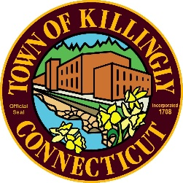
TOWN OF KILLINGLY
TOWN OF KILLINGLY
SOLID WASTE SUBCOMMITTEE
August 25, 2021, at 6:00 P.M.
KILLINGLY TOWN HALL
TOWN MEETING ROOM
172 Main Street, Killingly CT 06239
Commission Members:
Jason Anderson – absent with notification
Ernest Lee, chair
Ed Grandelski

Minutes
- Call to Order: Ernest Lee called the meeting to order at 6:00pm
- Citizens Comments: None
- Adoption of Minutes:
  - May 26, 2021, Meeting Minutes
Ed Grandelski motion to accept the minutes as written, Ernest Lee second, all in favor motion passed.
- Tim DeVivo- Casella / Willimantic Waste Paper Co. Inc.
Tim DeVivo introduces Brian Hovey the Market Area Manager for Casella Waste Systems, the new owners of Willimantic Waste Paper Co. The transition between the two companies should go smoothly. Contracts will remain the same.
- Finance Report: Jennifer Hawkins, finance director submitted the finance report. David Capacchione stating that nothing out the ordinary and everything is on track, discussion ensued. Ed Grandelski motioned to accept the finance report seconded Ernie Lee all in favor motion passes.
- Unfinished Business
  - DEEP-Municipal Waste Reduction Initiative
David Capacchione, nothing to report
- New Business:
  - Tonnage Report: David Capacchione gave an overview of the tonnage report.
- Other Discussion Items: None
- Adjournment: Ed Grandelski motion to adjourn, seconded by Ernest Lee all in favor motion approved. Next Meeting is on November 10, 2021
Respectfully submitted,
Joan Blymiller
Recording Secretary

