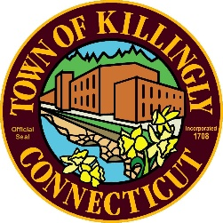
TOWN OF KILLINGLY
TOWN ENGINEER'S OFFICE
172 Main Street, Danielson, CT 06239
Tel: 860-779-5360 Fax: 860-779-5392
TOWN OF KILLINGLY
SOLID WASTE SUBCOMMITTEE
IN PERSON MEETING
April 27, 2022, at 6:00 P.M.
KILLINGLY TOWN HALL
TOWN MEETING ROOM

Commission Members:
Ed Grandelski
Kevin Kerttula
Andrew Whitehead

Minutes
- Call to Order: Andrew Whitehead called the meeting to order at 6:00pm.
All members present.

- Citizens Comments: none

- Adoption of Minutes:
  - March 3, 2022, Special Meeting Minutes
Ed Grandelski motioned to approve the minutes as presented, Kevin Kerttula seconded, all if favor, motion approved.
- Casella / Willimantic Waste Paper Co. Inc.: none
- Finance Report: David Capacchione submitted the finance report, everything is on track. Kevin Kerttula motioned to accept the finance report as submitted, Ed Grandelski seconded, all in favor, motion approved.
- Unfinished Business
  - DEEP-Municipal Waste Reduction Initiative: Bottle bill still is in legislation.

- New Business:
  - Tonnage Report: Kevin Kerttula motioned to accept the tonnage report, Ed Grandelski seconded, all in favor, motion passed.
- Other Discussion Items: none
- Adjournment: Ed Grandelski motioned to adjourn Kevin Kerttula seconded, all in favor, motion passed. Meeting adjourned at 6:07pm

Next meeting July 27, 2022 – 6:00 pm

Respectfully submitted,
Joan Blymiller
Recording Secretary

