Killingly Community Garden Committee
REGULAR MEETING

Wednesday, November 01, 2017
7:00 p.m.
Killingly Town Hall
172 Main Street, Killingly CT 06239
Room 102

AGENDA
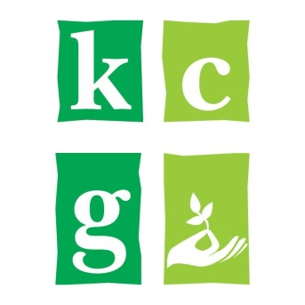
I. Call to Order and Roll Call
A. Welcome and Introductions
II. Approval of Minutes
- October 04, 2017 – Regular Meeting
III. Citizens Comment – (Individual presentations not to exceed 3 minutes; limited to an aggregate of 21 minutes unless otherwise indicated by a majority vote of the Committee)
IV. Ongoing Business – review/discussion/action
- Workshop Meeting with Agriculture Commission Members
(AG Commission to open their meeting)
  - Introduction – AG COMM (review/discussion/action)
  - 2017 Garden Report – short term and long term (review/discussion/action)
  - Plus/Delta Exercise - (review/discussion/action)
  - Putnam Community Garden Visit Recap (review/discussion/action)
  - Review Goals – short and long term (review/discussion/action)
  - 2018 Growing Season – goals, plans, suggestions (review/discussion/action)
  - Community Outreach / Educational Programs (review/discussion/action)
  - Grant Requirements (review/discussion/action)
  - Management Review (review/discussion/action)
  - New Business (review/discussion/action)
(AG Commission to close their meeting)
V. Next Meeting – Wednesday, December 06, 2017
VI. Adjournment

