Killingly Community Garden Committee
REGULAR MEETING
WEDNESDAY May 4, 2016
7:00 p.m.
Killingly Town Hall
172 Main Street, Killingly CT 06239
Room 102

AGENDA
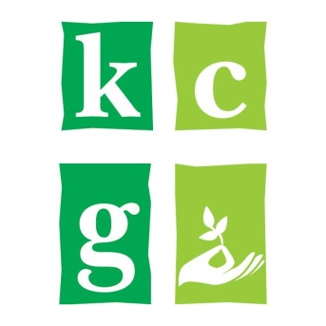
I. Call to Order and Roll Call
A. Welcome and Introductions
II. Approval of Minutes
A. November 4, 2015 Regular Meeting
B. February 10, 2016 Special Meeting
C. March 6, 2016 Special Meeting
D. April 6, 2016 Regular Meeting
E. April 16, 2016 Special Meeting

III. Ongoing Business
A. Michaela’s Garden
B. Student Workers Projects
C. Bylaws and Vision
D. Fundraising
E. Community Garden Funds
F. Five Year Plan
G. Other

IV. New Business
A. Election of Officers
B. Other

V. Next Meeting – Wednesday, June 1, 2016

V. Adjournment

