Killingly Community Garden Committee
SPECIAL MEETING
SUNDAY MARCH 6, 2016
11:30 AM
MEET AT KILLINGLY COMMUNITY GARDEN
79 WESTFIELD AVE, Killingly CT 06239

AGENDA
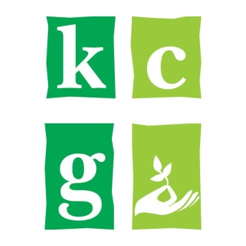
I. Call to Order and Roll Call
A. Welcome and Introductions

II. Ongoing Business
A. Garden Planning for 2016

III. Adjournment

