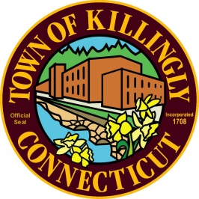
OFFICE OF THE TOWN MANAGER
172 Main Street, Killingly, CT 06239
Tel: 860-779-5335 Fax: 860-779-5382

NOTICE OF MEETING

Killingly Town Council
Organizational Meeting
Monday, December 4, 2017, 8:00 p.m.
**Please arrive by 7:45--pictures will be taken prior to the meeting**

Town Meeting Room (Second Floor)
Killingly Town Hall, 172 Main Street, Killingly, CT 06239

AGENDA

1. Call to Order – Town Clerk
2. Oath of Office - Town Clerk
3. Election of Chairman/Vice-Chairman
4. Discussion of appointment of Town Attorney
5. Consideration and action on a resolution appointing the Town Council’s recording
secretary
6. Consideration and action on a resolution establishing the date, time, and place
of 2018 and 2019 regular Town Council meetings
7. Consideration and action on a resolution adopting the Town Council’s Rules of Procedure
8. Discussion of Town Council liaisons to boards and commissions
9. Discussion of Assistant Town Manager position in upcoming budget year
10. Council Chairman Message
11. Adjournment

