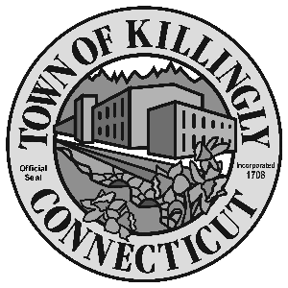

OFFICE OF THE TOWN MANAGER
172 Main Street, Killingly, CT 06239
Tel: 860-779-5335 Fax: 860-779-5382

TOWN OF KILLINGLY
FISCAL SUB-COMMITTEE MEETING
September 26, 2017
5:30 p.m.
Room 204, 2nd floor
Killingly Town Hall
172 Main Street, Killingly, CT

Council Members:
Kevin Ide, Chair
Ed Grandelski
Gail Oakley Pratt
David Griffiths, Alt.
Agenda

- Call To Order
2. Citizens Participation
3. Adoption of Minutes of Previous Meeting: July 27, 2017
4. Unfinished Business
5. New Business:

  - Budget Transfers for FY 2016-17.
  - Assign funds from FY 2016-17 year-end surplus from Unassigned Fund Balance to Winter Maintenance Assigned Fund (not to exceed $80,000) and to Rate Stabilization Fund (not to exceed $500,000).
  - Transfer of $123,073.93 from closed LOCIP-funded capital projects to current LOCIP-funded capital projects.

6. Other
7. Adjournment

