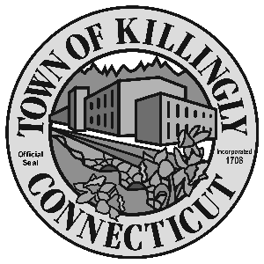
0 z

172 Main Street, Killingly, CT 06239
Tel: 860-779-5335 Fax: 860-779-5382

TOWN OF KILLINGLY
BOARD OF ASSESSMENT APPEALS

April 27, 2021
6:00 p.m.
Killingly Town Hall
Town Meeting Room

Members:
Dale Dauphinais
Kevin Gaudreau
Russell E. Lavigne II

Public can view the meeting on Facebook Live. Go to www.killingly.org click on Facebook Live.

Agenda

- Call to order
- Citizen’s participation
Pursuant to Governor’s Executive Order 7B, all public comment can be emailed to
publiccomment@killinglyct.gov or mailed to Town of Killingly, 172 Main Street,
Killingly, CT 06239 on or before the meeting. All public comment received prior to the meeting will be posted on the Town’s website www.killingly.org.

3. Adoption of minutes: February 23, 2021 workshop
4. Unfinished business - None
5. New business: Appeals from the 2020 Grand List

  - Adam Matteau, 75 Bear Hill Road
  - Benjamin Chase, 122 Lake Road
  - Ashley Pearson, 11 Blumenthal Drive
  - AT&T, 498 Putnam Pike
  - John & Mary Burke, 3 Lawton Lane
  - Frank & Debra Defelice, 329 Putnam Pike
  - Melina Mitchell, 100 Island Road

6. Adjournment

