Killingly Community Garden Committee
SPECIAL MEETING
By-Laws Subcommittee
THURSDAY MARCH 10, 2016
7:00 p.m.
Killingly Town Hall
172 Main Street, Killingly CT 06239
Room 102

AGENDA
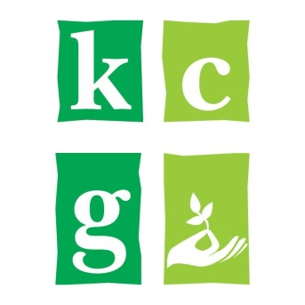
I. Call to Order and Roll Call
A. Welcome and Introductions

II. Ongoing Business
A. Vision and By-Laws review and update

III. Adjournment

