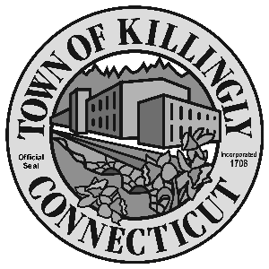
0 z

OFFICE OF THE TOWN MANAGER
172 Main Street, Killingly, CT 06239
Tel: 860-779-5335 Fax: 860-779-5382

TOWN OF KILLINGLY
FISCAL SUBCOMMITTEE MEETING
March 12, 2019
6:30 p.m.
Killingly Town Hall
Town Manager’s Office
172 Main Street, Killingly, CT

Council Members:
Jonathan Cesolini
David Griffiths
Alt: Ed Grandelski

Agenda

- Call to order
2. Citizens participation
3. Adoption of minutes: October 9, 2018
4. Unfinished business
5. New business:
  - Discussion of 2017-2018 Budgetary Transfers

6. Other
7. Adjournment

