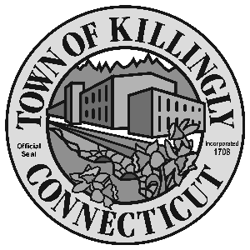

TOWN MANAGER’S OFFICE
172 Main Street, Killingly, CT 06239
Tel: 860-779-5335 Fax: 860-779-5382

TOWN OF KILLINGLY
FISCAL SUB-COMMITTEE MEETING
January 19, 2016
7:00 p.m.
Room 102, 1st floor
Killingly Town Hall
172 Main Street, Killingly, CT

Council Members:
Ed Grandelski
Kevin Ide
Gail Pratt Oakley
David Griffiths, Alt.
Agenda

- Call To Order – Town Manager
- Election of Officers
3. Citizens Participation
4. Adoption of Minutes of Previous Meeting: November 24, 2015
5. Unfinished Business
6. New Business:
  - Setting monthly meeting day (time)
  - Discuss accepting a Security Grant for school buildings. As well as a resolution appropriating $88,095 from Fund Balance to the Security Upgrades Capital Project in required matching funds to said capital project.
  - Discuss a resolution to authorize the replacement of the macerator at the WPCA plant using the Capital Non-Recurring account funds dedicated to this equipment.
  - Discuss designating the Fiscal Sub-Committee of the Town Council to be the Trust Fund Committee for several Library Trusts

  - Discuss a resolution that would authorize the Revenue Collector to waive refunds that are under $5.00.

7. Other
8. Adjournment

