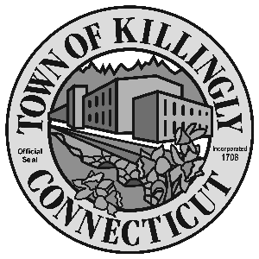

OFFICE OF THE TOWN MANAGER
172 Main Street, Killingly, CT 06239
Tel: 860-779-5335 Fax: 860-779-5382

TOWN OF KILLINGLY
FISCAL SUBCOMMITTEE MEETING
March 21, 2018
6:00 p.m.
Killingly Town Hall
Room 204
172 Main Street, Killingly, CT

Council Members:
Jason Anderson
Jonathan Cesolini
David Griffiths
Alt: Ed Grandelski

Agenda

- Call to order--TM
2. Appointment of subcommittee chair
3. Citizens participation
4. Adoption of minutes: September 26, 2017
5. Unfinished business
6. New business:

  - Change of custodian/asset advisor of ToK pension plan. Appointment of Charles Schwab Bank as custodian.
  - Appointment of Hooker and Holcombe Investment Advisors, Inc. as Discretionary Investment Fiduciary Advisors for the Town.
  - Approval of use of Killingly Public Library Trust fund for crack sealing and seal coating work in KPL parking lot. (see attached memos).
  - Funding for ADA projects at KCS and KMS (see attached memo).

7. Other
8. Adjournment

