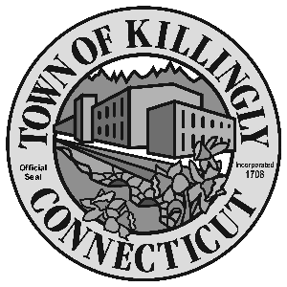
z

OFFICE OF THE TOWN MANAGER
172 Main Street, Killingly, CT 06239
Tel: 860-779-5335 Fax: 860-779-5382

TOWN OF KILLINGLY
FISCAL SUBCOMMITTEE MEETING
May 8, 2018
6:30 p.m.
Killingly Town Hall
Room 204
172 Main Street, Killingly, CT

Council Members:
Jason Anderson
Jonathan Cesolini
David Griffiths
Alt: Ed Grandelski

Agenda

- Call to order
2. Citizens participation
3. Adoption of minutes: April 11, 2018
4. Unfinished business
5. New business:

  - Discussion of CIRMA’s rate cap proposal for Liability-Auto-Property (LAP) insurance coverage.
  - Discussion of NECCOG land sale financing.
6. Other
7. Adjournment

