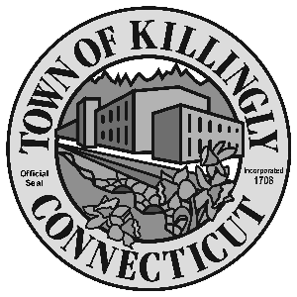

OFFICE OF THE TOWN MANAGER
172 Main Street, Killingly, CT 06239
Tel: 860-779-5335 Fax: 860-779-5382

TOWN OF KILLINGLY
FISCAL SUB-COMMITTEE MEETING
July 27, 2017
6:30 p.m.
Room 204
Killingly Town Hall
172 Main Street, Killingly, CT

Council Members:
Kevin Ide, Chair
Ed Grandelski
Gail Oakley Pratt
David Griffiths, Alt.
Agenda

- Call To Order
2. Citizens Participation
3. Adoption of Minutes of Previous Meeting: March 15, 2016
September 20, 2016
4. Unfinished Business
5. New Business:
  - Approval of use of funds from the Adolph H. Goldwater fund.
  - Approval of use of funds from the Lena Tripp fund.

6. Other
7. Adjournment

