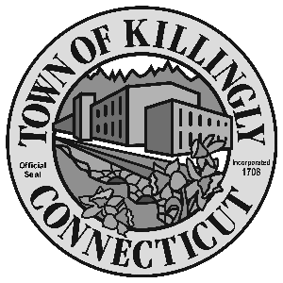

OFFICE OF THE TOWN MANAGER
172 Main Street, Killingly, CT 06239
Tel: 860-779-5335 Fax: 860-779-5382

TOWN OF KILLINGLY
FISCAL SUB-COMMITTEE MEETING
September 20, 2016
6:30 p.m.
Room 102, 1st floor
Killingly Town Hall
172 Main Street, Killingly, CT

Council Members:
Kevin Ide, Chair
Ed Grandelski
Gail Oakley Pratt
David Griffiths, Alt.
Agenda

- Call To Order
2. Citizens Participation
3. Adoption of Minutes of Previous Meeting: March 15, 2016
4. Unfinished Business
5. New Business:
  - Discussion of Budget Transfers for Fiscal Year 2015 - 2016.
  - Discussion of transfer of remaining funds from the Town of Killingly Conservation Commission, the Inland Wetlands & Watercourses Commission and the Agriculture Commission to the Open Space Land Acquisition Fund.
  - Consideration and Action on request for repair of the Library main entrance using the Bassett-Hammond Fund.
  - Consideration and Action on request to purchase a sign for the Library Community Room using the Frederick A. Jacobs Fund.
  - Discussion of Financial Policies for the Town of Killingly.

6. Other
7. Adjournment

