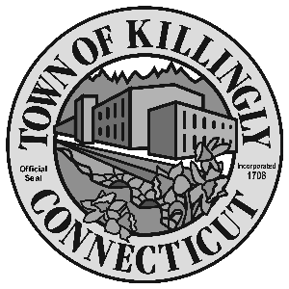
0 z

172 Main Street, Killingly, CT 06239
Tel: 860-779-5335 Fax: 860-779-5382

TOWN OF KILLINGLY
BOARD OF ASSESSMENT APPEALS

March 8, 2022
6:00 p.m.
Killingly Town Hall
Town Meeting Room

Members:
Dale Dauphinais
Kevin Gaudreau
Russell E. Lavigne II

Agenda

- Call to order
- Citizen’s participation
3. Adoption of minutes: September 14, 2021
4. Unfinished business - None
5. New business: Appeals from the 2021 Grand List
a. Rick Ouellette – 63 Academy Street
b. John & Patricia Farrell – 199 Lakeview Lane
c. Richard & Kerri Hall – 2007 Jeep Liberty & 2008 Volvo XC 90

6. Adjournment

