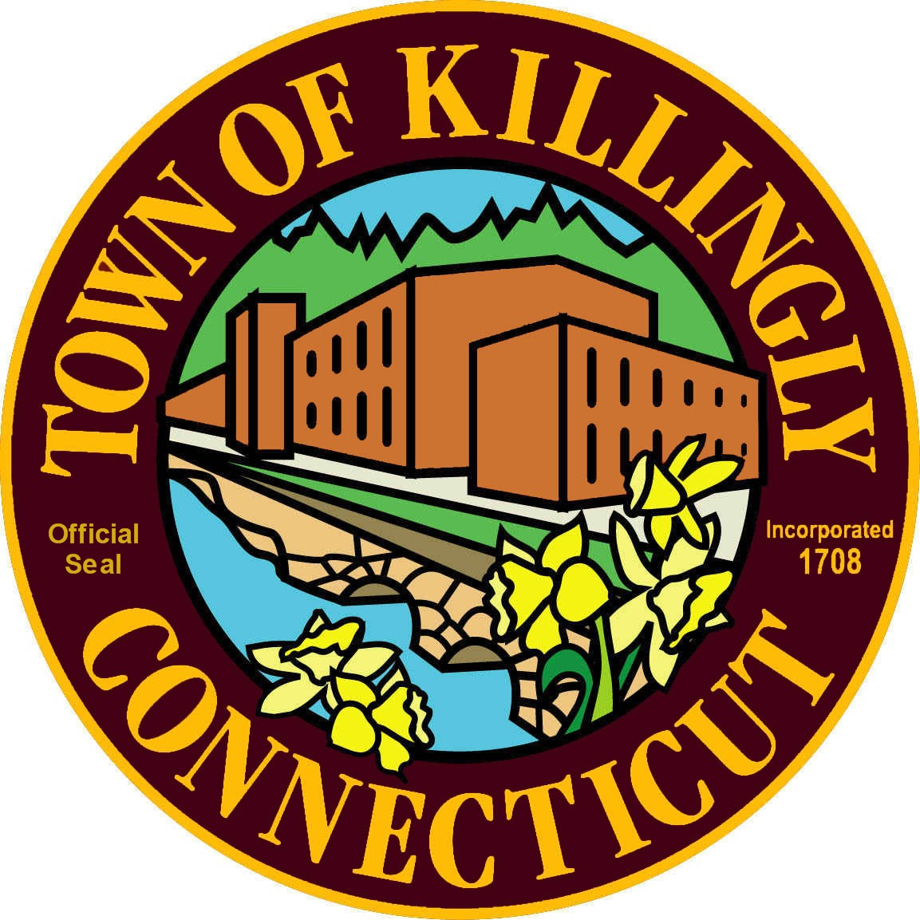TOWN OF KILLINGLY

OFFICE OF THE TOWN MANAGER
172 Main Street, Killingly, CT 06239
Tel: 860-779-5335 Fax: 860-779-5382

PERSONNEL SUBCOMMITTEE MEETING
Monday, May 13, 2019
6:30 p.m.
Town Manager’s Office
Killingly Town Hall, 172 Main Street, Killingly

Council Members:
Jason Anderson
Jon Cesolini
Adam Griffiths
David Griffiths, Alt.

Meeting Agenda

- Call To Order

- Citizens’ Participation

- Adoption of minutes of previous meetings:
- April 15, 2019
- November 5, 2018

- New Business
- Discussion/recommendation appointing the Director of Highway Operations

- Old Business

- Executive Session
- Discussion/recommendation appointing the Director of Highway Operations

7. Adjournment

