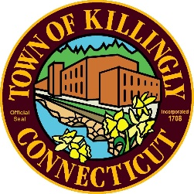
TOWN OF KILLINGLY
TOWN ENGINEER'S OFFICE
172 Main Street, Danielson, CT 06239
Tel: 860-779-5360 Fax: 860-779-5392
TOWN OF KILLINGLY
SOLID WASTE SUBCOMMITTEE
SPECIAL MEETING AGENDA
February 10, 2021 at 5:30 P.M.
KILLINGLY TOWN HALL
TOWN MEETING ROOM
172 Main Street, Killingly CT 06239
The Public can view the meeting on Facebook Live.

Go to https://www.facebook.com/KilIingly/TM/
CITIZEN'S STATEMENT AND PETITION
Pursuant to Governor's Executive Order 7B, all public comment can be emailed to publiccomment@killinglyct.gov or mailed to Town of Killingly, 172 Main Street, Killingly,
CT 06239 on or before the meeting. All public comment received prior to the meeting will be posted on the Town's website www.killing!yct.gov.
Commission Members:
Jason Anderson
Ernest Lee
Ed Grandelski

Agenda
- Call to Order
- Citizens Comments
- Adoption of Minutes:
  - November 19, 2020 Meeting Minutes
- Tim DeVivo- Willimantic Waste Paper Co. Inc.
- Finance Report
- Unfinished Business
  - DEEP-Municipal Waste Reduction Initiative
- New Business:
  - Tonnage Report
- Other Discussion Items
- Adjournment
Visit us on the web at WWW.KILLINGLYCT.GOV

