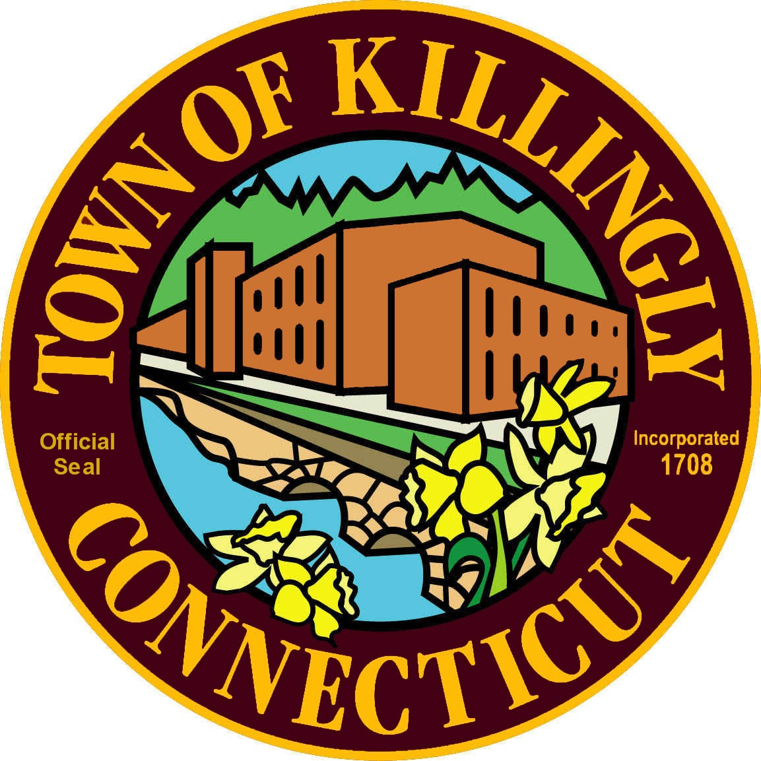TOWN OF KILLINGLY

OFFICE OF THE TOWN MANAGER
172 Main Street, Killingly, CT 06239
Tel: 860-779-5335 Fax: 860-779-5382

PERSONNEL SUBCOMMITTEE MEETING
Tuesday, December 1, 2020
6:30 p.m.
Town Meeting Room
172 Main Street
Killingly, CT 06239
(Commission members only)

Council Members:
Kevin Kerttula
Ernest Lee
Ray Wood

Public can view the meeting on Facebook Live. Go to www.killinglyct.gov click on Facebook Live.
Meeting Agenda

- Call to Order

- Citizens’ Participation

Pursuant to Governor’s Executive Order 7B, all public comment can be emailed to
publiccomment@killinglyct.gov or mailed to Town of Killingly, 172 Main Street,
Killingly, CT 06239 on or before the meeting. All public comment received prior to the meeting will be posted on the Town’s website www.killinglyct.gov.

- Adoption of minutes of previous meetings:
- July 28, 2020

- New Business
- Discussion/recommendation appointing the Assessor.

- Executive Session
- Personnel Matter – appointing the Assessor
- Collective Bargaining Negotiations – Town Hall Union

6. Adjournment

